WK 4 Midterm Project

Sean Coggeshall
American Military University
ITCC231 Into. to Information Technology Writing
Professor Cain
July 30, 2022

WK 4 Midterm Project

Professional Article
During my time at work we sometimes have users reach out about their Lenovo Laptop not powering on at all. We at the Service Desk are familiar with the issue as we see it often, but the user usually does not know where to start. This is an article that I reference users to often, it is a guide on how to do a Lenovo Pinhole reset. It helps the end user reset their laptop and most of the times resolves the issue. We use this article because it helps the end user with the where, when, and how of the reset button. The most difficult part for technicians is usually describing where to find the pin hole reset. If we can have them access this article from their smart phone or personal computer, it helps having the visual to find the reset. If they cannot access the website, it still helps us technicians with describing where to find it.
Schools Website
Looking at AMU’s website when I was a potential transfer student. There were multiple features that I found most useful. First, it targeted the audience immediately. With the word military being in the name and all over the main page, it is showing that they are open to our personal challenges.
There are multiple ways to apply right on the initial page. It offers both an “Apply Now” option (which I believe is what I used), a number to call, and a section to just fill out contact information if you are still deciding if you would like to attend and what major to apply for.
The section for deciding what major you would like to apply for is to towards the bottom of the page. I think this should be located more towards to the top or provide a link at the top for the user to jump to that section of the page. Deciding what major to apply for is one of the most stressful parts of the process and for that reason I think the program description section should be more easily accessible.
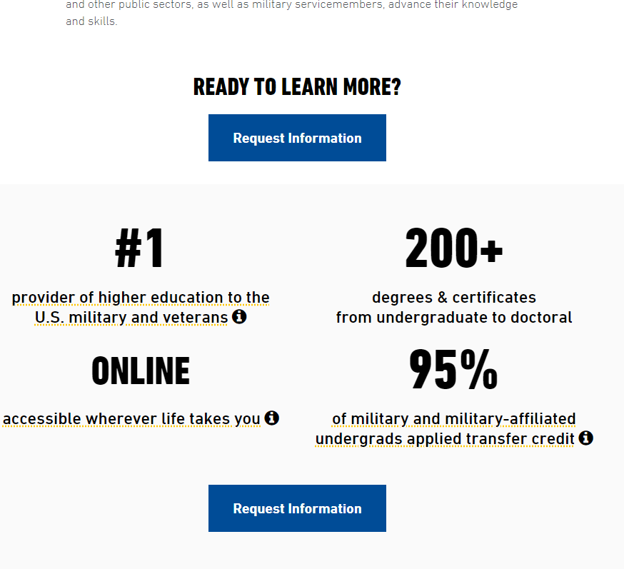
For instance, this section of the page has links and additional information on all facts except the degrees offered. You would have to keep scrolling down to the bottom of the page to find that.
I would also add how the semesters are designed, I think the eight (8) month classes are big highlight of AMU and should be listed somewhere on the home page.
Bulletin Rework
All supervisors must be conscious of the need to reduce costs and properly use available security guards in the most effective manner.
- Every effort should be made to eliminate non-security service functions, such as airport pickup, mail runs, drives to banks, drives to medical centers, parcel pickup. Non-security service functions should be contracted out if possible. Drives to banks should be performed by the responsible department, but a department may request a security guard escort.
- The supervisors should regularly review the schedule to be sure the coverage meets the needs of the plant. Consider staggering the start and quit times to ensure a larger force during the peak demand hours.
- Guards assigned to gates should advise the shift supervisors whenever they leave their posts, including for lunch break.
- Guards assigned to patrols, shipping and receiving docks, and special surveillance should tell the shift supervisors when they leave their assigned task, even for the lunch break.
- Supervisors should consider combining spot checks with regular duties of guards. For example, if a guard must open a gate and passes the trash center, the guard can spot check the trash pickup on the way to or from opening the gate.
- Supervisors must know about outside employment of guards. Guards who operate small businesses may resist the normal rotation because it will interfere with their outside employment. Security requires a 7-day operation.
- These outside activities should not adversely affect the security arrangements at the plant. In general, security guards should not also work at racetracks or casinos, or any places associated with gambling.
- Guards also should not be in partnership with co-workers since that relationship could negatively affect plant security. Supervisors need to check attendance records regularly.
- Frequent illness may indicate the guard cannot do the physical tasks appropriately. Questionable illness reports should be checked.

Real World Bulletin
A real-world bulletin I went over was Instagram’s instructions on “What can I do if I’ve been phished on Instagram?”. Overall this is written very well, it is Instagram so I would expect that from such a large company. Almost nothing to critique except I think these articles should be made aware of. For these help articles you have to go out and search for it, yet I probably see three spam/phishing messages a day on the app. I think the best location for them to provide this link with this information is on the direct message requests tab. That way people can be made aware of these attacks before they need to get their account back.

Frequent Website
A website I use often is Instagram. It has changed drastically since I first started using it in regard to appearance. Functionality has really only changed a little. There are no distracting elements (beyond the app itself is a distraction), it starts on the main feed page where users spend most of their time. Stories are located at the top, which are photos that can be viewed for 24 hours before they disappear. I remember when stories first got added it was a big deal because everyone was saying how they just copied snapchat, which they did, but they left the function, and everyone has sense gotten used to it. They are going through this again in context with the new “reel” function, which is just their version of TikTok. They continue to adapt to the way users interact with apps for entertainment and stay up to date on the new trends.

Ford, Chrysler, General Motors Review
Ford® - New Hybrid & Electric Vehicles, SUVs, Crossovers, Trucks, Vans & Cars
Chrysler Official Site - Cars and Minivans
General Motors: Pushing the Limits of Transportation & Technology (gm.com)
For a senior user going to these websites, Chrysler would be the most difficult. The sliding images on the home screen can be difficult to click if you are not quick with your mouse. Some users may not notice the pause button they have located in the top right corner of the slides and even if they did it is rather small which could make difficult for some users to click.
Ford seems to be the easiest as it has large, still graphics. The tabs are straight forward with what they provide information on. They also keep the options to a small minimum, so it is not overwhelming the end user.
General Motors is somewhere in the middle. The drop-down selections can be difficult to find or once found difficult to click as they are sensitive features. There really is not too much direction on the top of the homepage and you would have to dig into the website to find the information you need to make a purchase decision.
Websites for sales should be bold, informative, and simple for senior users to easily access the information the need. Try to avoid fast moving slides, if needed make sure the arrow function is available with long delay times between rotation. Larger images that take up most of the page are better than multiple small ones, try to keep the images on the home screen to one or two large pictures. Keep link options to only the necessary information. The more options will lead to confusion.

Online Company Product Task
Adding a Shared Mail Inbox to Outlook-
First, we will need to make sure you have the correct access to the Group. If you are unaware of your access, please reach out to your manager or Systems Administrator.
- Open Outlook
- Click “File” located in the top left corner of your screen
- Click “Add Account”. (image below)
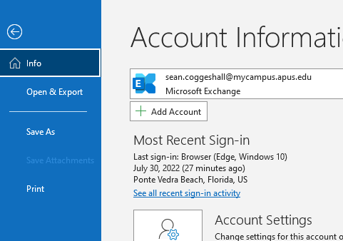
- A pop-up window will appear, enter the email address of the inbox you would like to add.
- Click “Connect”.
You should then receive an “account added successfully” message. If not, please proceed to the following steps.

- Open Outlook if not already opened.
- Right Click your email address in the left pane. (image below)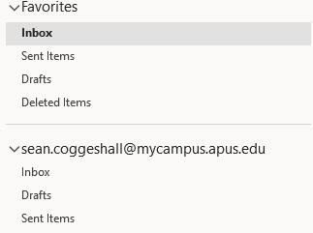
- Click “Data File Properties” on the bottom of the pop up.
- Click “Advanced” – another pop up will appear.
- Click the “Advanced Tab”.
- Click “Add” then enter the email address.
- Click “OK”
- Click “Apply”
- Click “OK”.
The email address should now be added to your inbox. If you are receiving a “Access Denied” or “You Do Not Have Permission To Access This Folder” error, please reach out to your manager for an access request. For all other errors please submit a help ticket here – https://www.servicenow.com

References

CAIU Helpdesk. (2020). Security check. Reset Lenovo Laptop Via The Reset Hole. Retrieved July 29, 2022, from https://support.caiu.org/hc/en-us/articles/360039880873-Reset-Lenovo-Laptop-via-the-Reset-Hole

American Military University. (2022). Online Degrees. Retrieved July 29, 2022, from https://start.amu.apus.edu/?msclkid=adf7605413121a3a1f1602b7f581f137&utm_source=bing&utm_medium=cpc&utm_campaign=AMU%20-%20SN%20-%20AMU&utm_term=american%20military%20university&utm_content=American%20Military%20University%20-%20Exact#level=bachelor

‌ Basic tasks in Word. (n.d.). Support.microsoft.com. Retrieved July 30, 2022, from https://support.microsoft.com/en-us/office/basic-tasks-in-word-87b3243c-b0bf-4a29-82aa-09a681999fdc#:~:text=1%20Start%20a%20document.%20It%E2%80%99s%20often%20easier%20to
‌
Help Center. (n.d.). Help.instagram.com. Retrieved July 30, 2022, from https://help.instagram.com/670309656726033/?helpref=uf_share
‌
Meta. (2022). Login • Instagram. Instagram Login. Retrieved July 29, 2022, from https://www.instagram.com/accounts/login/

Ford Motor Company. (2022). Ford® - New Hybrid & Electric Vehicles, SUVs, Crossovers, Trucks, Vans & Cars. Retrieved July 29, 2022, from https://www.ford.com/

Chrysler Official Site - Cars and Minivans. (2022). Chrysler. Retrieved July 29, 2022, from https://www.chrysler.com/?sid=913821&KWNM=chrysler&KWID=43700048880482378&TR=1&channel=paidsearch&gclid=af6a5cd87e3f19fc050d3e3cd915cce0&gclsrc=3p.ds&ds_rl=1267138&ds_rl=1267898&ds_rl=1273017&msclkid=af6a5cd87e3f19fc050d3e3cd915cce0

General Motors: Pushing the Limits of Transportation & Technology. (2022). General Motors. Retrieved July 29, 2022, from https://www.gm.com/

S. (2022, June 2). Create a shared mailbox - Microsoft 365 admin. Microsoft Docs. https://docs.microsoft.com/en-us/microsoft-365/admin/email/create-a-shared-mailbox?view=o365-worldwide#add-the-shared-mailbox-to-outlook

A. (2022, July 6). Free APA Citation Generator | Verified by Experts. Scribbr. https://www.scribbr.com/apa-citation-generator/

Laan, V. K., & Hackos, J. T. (2022). The Insider’s Guide to Technical Writing (2nd ed.). XML Press.

